Dependent Clause

✅ Definition:
# Source: AI Source: Provided by: [Data Path: Persons Table -> ID Column: 1, Name_En Column: Motasem Essam] -> From: [Chatgpt (GPT-4-turbo)] on [7/29/2025]
A dependent clause is a group of words that contains a subject and a verb, but does NOT express a complete thought.
It cannot stand alone as a sentence and needs an independent clause to complete its meaning.

🧩 Structure:
# Source: AI Source: Provided by: [Data Path: Persons Table -> ID Column: 1, Name_En Column: Motasem Essam] -> From: [Chatgpt (GPT-4-turbo)] on [7/29/2025]
Subordinator (e.g., because, although, when, who, that) + Subject + Verb

🧠 Key Features:
# Source: AI Source: Provided by: [Data Path: Persons Table -> ID Column: 1, Name_En Column: Motasem Essam] -> From: [Chatgpt (GPT-4-turbo)] on [7/29/2025]
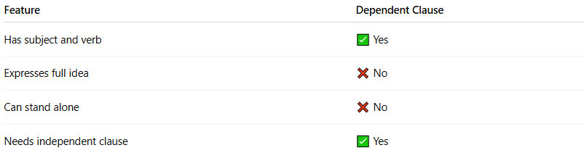
Feature | Dependent Clause
Has subject and verb | ✅ Yes
Expresses full idea | ❌ No
Can stand alone | ❌ No
Needs independent clause | ✅ Yes

✏️ Examples (Incomplete Alone):
# Source: AI Source: Provided by: [Data Path: Persons Table -> ID Column: 1, Name_En Column: Motasem Essam] -> From: [Chatgpt (GPT-4-turbo)] on [7/29/2025]
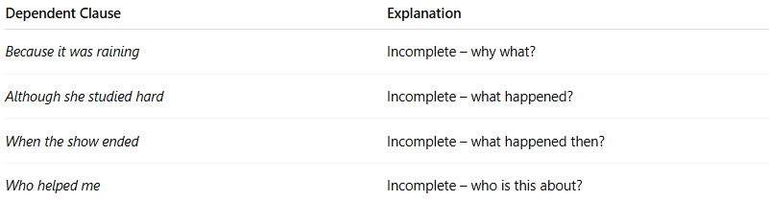
Dependent Clause | Explanation
Because it was raining | Incomplete – why what?
Although she studied hard | Incomplete – what happened?
When the show ended | Incomplete – what happened then?
Who helped me | Incomplete – who is this about?
➕ Add an independent clause to complete:
- Because it was raining, we stayed inside.
- She passed the test although she studied hard.
- When the show ended, the audience clapped.

📂 Three Main Types of Dependent Clauses:
# Source: AI Source: Provided by: [Data Path: Persons Table -> ID Column: 1, Name_En Column: Motasem Essam] -> From: [Chatgpt (GPT-4-turbo)] on [7/29/2025]
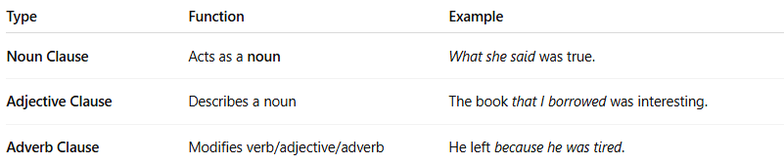

Type | Function | Example
Noun Clause | Acts as a noun | What she said was true.
Adjective Clause | Describes a noun | The book that I borrowed was interesting.
Adverb Clause | Modifies verb/adjective/adverb | He left because he was tired.

🚫 Common Subordinating Words (that start dependent clauses):
# Source: AI Source: Provided by: [Data Path: Persons Table -> ID Column: 1, Name_En Column: Motasem Essam] -> From: [Chatgpt (GPT-4-turbo)] on [7/29/2025]
Subordinating Conjunctions | Relative Pronouns
because, although, since, if, when, while, unless, after, before | who, whom, whose, which, that

🧠 Summary Table:
# Source: AI Source: Provided by: [Data Path: Persons Table -> ID Column: 1, Name_En Column: Motasem Essam] -> From: [Chatgpt (GPT-4-turbo)] on [7/29/2025]
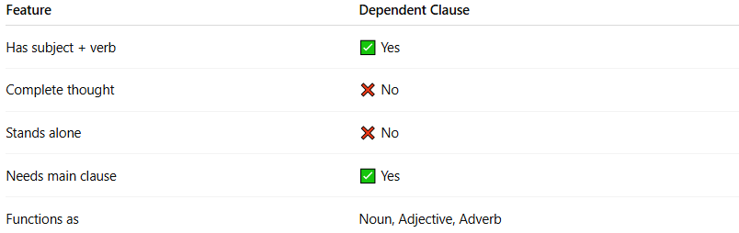
Feature | Dependent Clause
Has subject + verb | ✅ Yes
Complete thought | ❌ No
Stands alone | ❌ No
Needs main clause | ✅ Yes
Functions as | Noun, Adjective, Adverb

🧪 Quick Practice – Identify the dependent clause:
# Source: AI Source: Provided by: [Data Path: Persons Table -> ID Column: 1, Name_En Column: Motasem Essam] -> From: [Chatgpt (GPT-4-turbo)] on [7/29/2025]
- When she arrived at the station, the train had already left.
- I know that he is lying.
- The girl who sits near me is absent.
✅ Answers:
- 1 → When she arrived at the station = Adverb clause
- 2 → that he is lying = Noun clause
- 3 → who sits near me = Adjective clause

